Probability:
Probability means possibility. It is a branch of mathematics that deals with the occurrence of a random event. The value is expressed from zero to one. Probability has been introduced in Maths to predict how likely events are to happen.

- Mutual Exclusive Events:
- Non Mutually Exclusive Events:
- Multiplication Events:

Mutual Exclusive Events:
Two events are mutually exclusive if they can not occur at the same time. Example: Tossing a coin, Rolling a dice.

Non Mutually Exclusive Events:
Two events that occur at the same time.
Example:
- Picking marble from a bag of marbles where it contains Red, Green, and half Red and half Green.

Multiplication Events:
- Dependents Events: Two events are dependent if they affect one another.

Permutation:
A permutation is an arrangement of objects in a definite order. The members or elements of sets are arranged here in a sequence or linear order.

Example 01:
The permutation of set A={1,6} is 2, such as {1,6}, {6,1}. As you can see, there are no other ways to arrange the elements of set A.

Example 2:
The permutation of set B={1,4,5} is 6, such as
{1,4,5}{1,5,4}
{4,5,1}{4,1,5}
{5,1,4}{5,4,1} .
As you can see, there are no other ways to arrange the elements of set B.
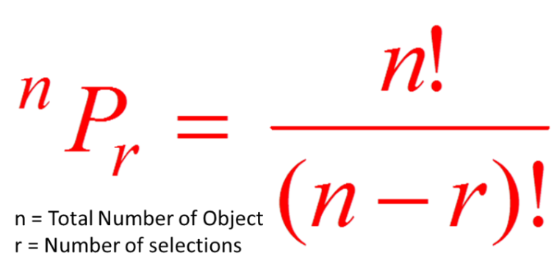

Combination:
A combination is a mathematical technique that determines the number of possible arrangements in a collection of items where the order of the selection does not matter with only unique combination where items are not repeating.

Example01:
The Combination of set A={1,6} is 1, such as {1,6}. As you can see, there are no other ways to arrange the elements of set A with a unique combination where items are not repeating..

Example 2:
The permutation of set B={1,4,5} is 3, such as {1,4,5}, {4,5,1}, {5,1,4}. As you can see, there are no other ways to arrange the elements of set B with unique combination where items are not repeating..

